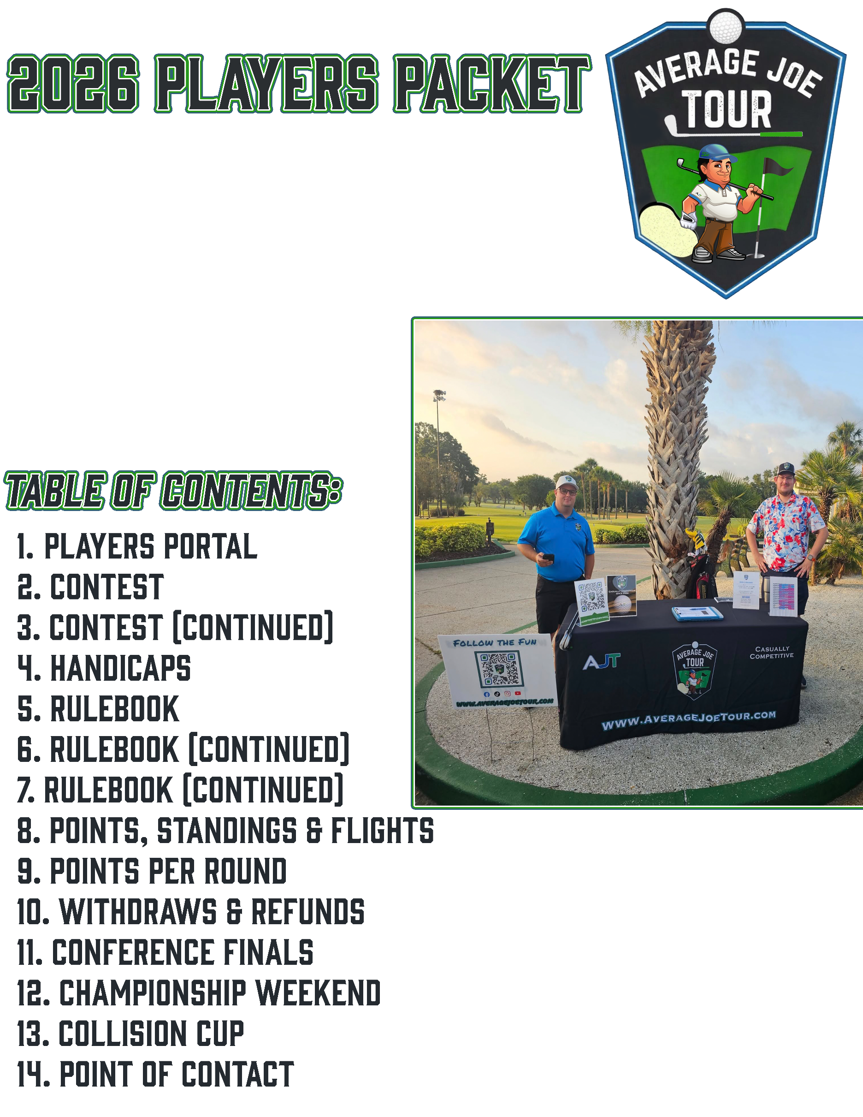



You will find the Players Portal at
www.averagejoetour.com/playersportal

The Players Portal is where you will find all the fun stuff you want to know, once the season kicks off.

Registration for each round will open 3 to 4 weeks prior.
The only mandatory requirement for each round are the green fees.
All other contest entries are optional.


Contest
All monetary “per round” contests and mulligans are non-mandatory. There will be an option to add-on while registering for each individual round.
These contests include the following.
- Net Score
- Closest to Pin(x2)
- Gross Skins
- Net Skins

Long drive is discontinued in 2026, with the decision to add a 2nd Closest to Pin.
All contests will be flight-based for rounds 4-8

ALL PLAYERS ARE AUTOMATICALLY ELIGIBLE FOR CHAMPIONSHIP PRIZES
Pending Championship qualification

NET SCORE
A competition based on a player’s score after handicap is applied.
This format allows golfers of different skill levels to compete fairly. The player with the lowest net score wins.
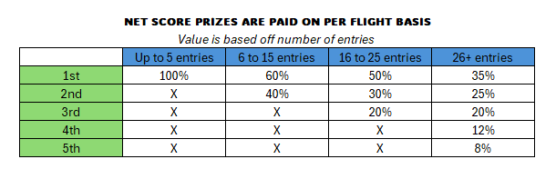

CLOSEST TO PIN
A skill contest typically held on a par-3 hole.
The player whose ball finishes closest to the hole on the tee shot wins the prize, regardless of score on the hole.
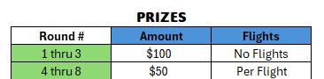

GROSS SKINS
A hole-by-hole competition based on actual (gross) score with no handicap.
A player wins a “skin” by recording the lowest score on a hole outright compared to all other players. You are scored only against other players who have opted into contest.
Prizes vary each round.

NET SKINS
Similar to Gross Skins, but handicaps are applied.
A player wins a skin by having the lowest net score on a hole after handicap adjustments, making it more accessible for players of all skill levels. You are scored only against other players who have opted into contest.
Prizes vary each round

.
STARTING IN 2026: ALL CONTEST ARE SCORED ON A “PER FLIGHT” BASIS
Valid only Rounds 4-8 & Postseason
HANDICAPS
Returning players will have their 2025 handicap carry over. If you are returning from a year prior to 2025, you will need to go through the same process as 1st year players.
First year players: Your A.J.T. handicaps will begin to establish after 1st round of season. First year players will be ineligible for NET SCORE and NET SKINS Prizes until three (3) A.J.T. Rounds have been completed. You will still receive points earned towards season standings.
Players with a GHIN or 18 Birdies will be able to use verified index to start the 2025 season.

MAX HANDICAP: 36

HANDICAP IS BASED OFF YOUR MOST SIX (6) RECENT A.J.T. ROUNDS, WITH 33% OF HIGH SCORES THROWN OUT.
FOR EXAMPLE:

If you shot the following scores: 86,90,91,92, 87,94
The scores of 94 and 92 would not be calculated into your handicap.

If you only have 3 scores: 86,90,91
Then only the 91 would be thrown out.

COURSE ADJUSTMENT: Your course index will adjust based on Course Rating, Slope Rating and course/tees you’re playing from that day.

RULEBOOK

Mulligans
- 1 Mulligan per 9 Holes
- Mulligans must be used from tee-box only
- Extra purchased Mulligans are to be used on Contest Holes Only.
- Contest Mulligans are played as best ball (Choose your favorite tee shot)
- 1 Mulligan per hole (No combining 9-Hole mulligan with contest mulligan).

During Shotgun Starts - Mulligans are based off your first 9 holes played and second 9 holes played.

"Gimmies"
- Standard putter length gimmies are allowed for double bogey or higher
- Must putt for Bogey or less
- Make sure to add the stroke for "gimmies"

Cap out at Double-Par
- Par 3 - 6 Strokes Max
- Par 4 - 8 Strokes Max
- Par 5 - 10 Strokes Max
​
​

Lift, Clean, & Place (Preferred Lies)
- Only Permitted in the fairway unless there is an immovable object that can cause harm or injury to player or golf club. For example, the cart path, a tree root, or ground under repair.
- Please move ball if it inbounds, but your stance requires you to be in someone's backyard.
- 1 Club Length max, no closer to the hole

Out of Bounds: Stroke and Distance
- White and Red Markers are not used on AJT.
- Player loses one stroke and receives distance for the shot. Players must hit from agreed upon area with grouping partners.
- If you feel that your tee-shot may be out of bounds, you can play a provisional ball to save time. You must announce to your group that you are playing a provisional ball before doing so.
- You cannot use provisional ball as a mulligan if you are able to find your original ball inbounds.
- Maximum time to look for a ball is 3 minutes with all players in group assisting on the search. After 3 minutes, you must take a drop and 1 stroke penalty.

Tee Box: Where to Play From
A.J.T. utilizes the tee box that is generally between 5700-6100 yards
This is generally the “White Tees”
Starting in 2026. Players aged 55+ will have the option of playing the forward tees (one tee box up from the rest of the players) Players must play all rounds from the forward tees. If a player chooses to play a round from the default tee box, they will lose forward tee privilege for the remainder of the season. This is for handicap purposes.
ALL CLOSEST TO PIN CONTEST MUST BE PLAYED FROM DEFAULT TEE BOX
Unplayable lies: No Penalty
- When there is an immovable obstruction that hinders your stance or swing, or a man-made obstruction between your ball and the hole impeding the possible ball flight, the ball can be moved without penalty. For example, your ball may have come to rest on a grate or a sprinkler head, necessitating a drop. If your ball lies near a hazard stake that impacts your stance or swing, and the stake can’t be temporarily removed, then it’s deemed an immovable object and you gain relief — no closer to the hole.
- Average Joe allows you to move ball away from cart path and tree roots without receiving Penalty. We are here for fun. Do not mess up your clubs.
- Casual water on the course enables you to move the ball without penalty. Generally, if your ball finishes there or your stance is affected (visible underfoot), then move your ball to the nearest point of relief, no closer to the hole. If water is on the green, come to an agreement with playing partners on where to putt from.
​
​
​Ready Golf: Must keep up with Pace of Play
- Use your discretion, but it is not always mandatory to have further ball play first.
- Kindly, hold slow players accountable.

​
Golf Etiquette
- Proper golf attire (No T-Shirts, No denim)
- Keep music at reasonable level
- Do not talk in partners back swing
- Do not talk while partners putting
- Leave course better than you found it
- Abide by all individual course rules

POINTS, STANDINGS, & FLIGHTS

Points: The points per round (PPR) differ for Rounds 1–3 compared with Rounds 4–8.
The point structure for Rounds 1–3 is designed to keep all participants in contention until flights are established at the conclusion of the third round.
Your six (6) best regular season PPR will determine where you fall in the standings. This gives you an opportunity to shake off a couple of bad rounds or be absent for up to two rounds without being penalized. (We understand everyone has lives of their own)

BONUS POINTS ARE DISCONTINUED FOR 2026: The new bonus will be raffle tickets for qualification into the 2027 Collision Cup.
6 rounds played = 1 Ticket
7 rounds played = 3 Tickets
8 rounds played = 5 Tickets
Tickets are eligible to carry over into future years until your name is drawn. Once drawn, you will go back down to zero (0) tickets.

Flights: In golf, flights are groups of players divided by skill level or performance, usually to make competition fairer and more competitive.
- Players are grouped after 3 rounds (based on handicaps).
- Each flight competes only against others in the same group.
- Net Score prizes and points are awarded separately for each flight
Green Flight: Lower Handicaps
Blue Flight: Higher Handicaps

FLIGHT LINE IS DETERMINED AT THE CONCLUSION OF ROUND 3

POINTS PER ROUND
ROUNDS 1-3 |  |  |  |  | ROUNDS 4-8
Place | Points | continued |  |  | Place | Points | continued
1st | 20 | 34th | 8 |  | 1st | 25 | 34th | 5.5
2nd | 17 | 35th | 8 |  | 2nd | 20 | 35th | 5.5
3rd | 15 | 36th | 7.5 |  | 3rd | 17 | 36th | 5.5
4th | 12 | 37th | 7.5 |  | 4th | 15 | 37th | 5.5
5th | 10 | 38th | 7.5 |  | 5th | 12 | 38th | 5.5
6th | 9.5 | 39th | 7.5 |  | 6th | 10 | 39th + | 5
7th | 9.5 | 40th | 7.5 |  | 7th | 9.5
8th | 9.5 | 41st | 7.5 |  | 8th | 9
9th | 9.5 | 42nd | 7.5 |  | 9th | 8.5
10th | 9.5 | 43rd | 7.5 |  | 10th | 8.5
11th | 9 | 44th | 7.5 |  | 11th | 8
12th | 9 | 45th | 7.5 |  | 12th | 8
13th | 9 | 46th | 7 |  | 13th | 8
14th | 9 | 47th | 7 |  | 14th | 7.5
15th | 9 | 48th | 7 |  | 15th | 7.5
16th | 8.5 | 49th | 7 |  | 16th | 7.5
17th | 8.5 | 50th | 7 |  | 17th | 7.5
18th | 8.5 | 51st | 7 |  | 18th | 7.5
19th | 8.5 | 52nd | 7 |  | 19th | 7
20th | 8.5 | 53rd | 7 |  | 20th | 7
21st | 8.5 | 54th | 7 |  | 21st | 7
22nd | 8.5 | 55th | 7 |  | 22nd | 7
23rd | 8.5 | 56th | 6.5 |  | 23rd | 7
24th | 8.5 | 57th | 6.5 |  | 24th | 6.5
25th | 8.5 | 58th | 6.5 |  | 25th | 6.5
26th | 8 | 59th | 6.5 |  | 26th | 6.5
27th | 8 | 60th | 6.5 |  | 27th | 6.5
28th | 8 | 61st | 6.5 |  | 28th | 6.5
29th | 8 | 62nd | 6.5 |  | 29th | 6
30th | 8 | 63rd | 6.5 |  | 30th | 6
31st | 8 | 64th | 6.5 |  | 31st | 6
32nd | 8 | 65th | 6.5 |  | 32nd | 6
33rd | 8 | 66th + | 6 |  | 33rd | 6

Withdraws and Refunds
Email: withdraw@averagejoetour.com
All withdrawals and refund requests must be emailed prior to 6:00am EST, the morning of your round. No exceptions.
Any approved refund will be processed in full, with a 3.5% processing fee deducted from the total amount.

Postponed/Cancelled Rounds
Suspended/Postponed Rounds: ​In the event a round is suspended due to inclement weather or other unforeseen circumstances
- ​​​While most incomplete rounds are due to weather, some are for other reasons. For weather, there must be a dangerous situation, or the course is unplayable for players to quit without getting penalized. If player withdrawals for personal reason or injury, they will be carded for double par on remainder of holes.
- Suspended Rounds are handled on a course-by-course basis, and refunds are based off each individual course discretion. For Example, If X-number of holes are played, courses may give each player a voucher. Average Joe Tour has no control over how this is handled.
- Postponed Rounds may happen due to inclement weather. AJT will notify each player as swiftly as possible once determined a course will be unplayable for the day. AJT will try to reschedule any postponed rounds within 3 weeks of scheduled date. Full Refunds will not be provided until a round is fully deemed "canceled". Requested refunds prior will be subject to 3.5% Processing Fee.
​​Scoring for Suspended Round:
- Based off the number of holes finished by all players in each flight. For example, if you are in the first group and finish all 18 holes but a player in the last group only finished 12 holes, then all players will be scored for holes 1-12 with every player receiving "net par" for holes 13-18. In this case, scores will not be calculated against handicaps.
- 9 holes must be completed by every player in respective flight for round to become official.


